USB Floppy Emulator 1MB (Introduction)

Prototype 1 designed in 2008 by Les Bird
lesbird@bellsouth.net

The USB Floppy Emulator 1MB is a hardware device designed to emulate a floppy disk drive. It has 1MB of onboard RAM, two 74LS240’s for buffering and inverting the signals to the floppy controller card, a jumper for selecting external or USB power source and an ICSP port for connecting the device to a PIC programmer/debugger. This design is currently in the prototype stage – it seems like it should work on paper but there has been no complete software package designed for it yet. It is a result of combining circuitry from other existing hardware onto a single, compact PCB. With the REV 1.2 design one jumper wire needs to be installed to connect the power pins of the two SRAM chips (pin 32). I simply forgot to complete the power track layout before submitting the Gerber files to the manufacturer. Later versions of the design will have this error corrected. Without this jumper wire, chip U3, U6 and U7 will not get power and the ICSP port will not work.
Why a floppy disk emulator?
There are a couple floppy disk emulators existing that I know of with the SVD being the most popular (www.thesvd.com). There are limitations with the original SVD design. First, it only has 256K of RAM onboard for storing disk images. Second, it is hard-programmed to emulate disk formats for certain supported systems. Third, it uses the somewhat outdated RS232 serial port for sending and receiving disk images. The creator of the SVD was going to redesign it to correct these limitations but after more than a year there has been no word on any success. During this time I’ve been tinkering around with several designs of my own and the result is the USB Floppy Emulator 1MB.
A hardware floppy emulator has several advantages with the main one being reliability. With a floppy emulator you can archive your old floppy disks to your PC and the disk images saved in this fashion will last infinitely longer than your actual floppy disks resulting in reliability of software. In addition, since there are no mechanical moving parts the device requires no drive alignment of any kind and will last much longer than a real floppy disk drive resulting in reliability of hardware. For vintage computer collectors this is an extremely valuable device. What good are those old computers if the disks are unreadable or the drives are not working anymore? A floppy emulator is the solution to these problems.

USB Floppy Emulator 1MB (Pin Assignments)

The following table shows the PORT connections on the PIC in relation to the 34pin IDC connector. Signal direction is relative to the PIC. Floppy controller pins not supported are pin 2 (disk change), pin 4 and 6 which are not defined and pin 34 (disk ready).
PIC DIRECTION IDC DESC
02 RA0 -> 08 /IDX Sector index pulse
03 RA1 <- 10 /DS0 Device select 0
04 RA2 <- 12 /DS1 Device select 1
05 RA3 <- 14 /DS2 Device select 2
06 RA4 <- 16 /MON Motor on
07 RA5 -> 26 /TR0 Track 0
08 RE0 <- 18 /DIR Step direction
09 RE1 -> 28 /WPT Write protect
10 RE2 <- 20 /STP Track step
15 RC0 -> MEMINC Memory pointer increment
16 RC1 -> /MEMWRT Memory write enable
17 RC2 -> MEMCLR Memory pointer reset
RD0-RD7 <-> Memory byte to/from RAM
33 RB0 -> 30 /RDT Read data
34 RB1 <- 22 /WGT Write gate
35 RB2 <- 32 /SID Side select
36 RB3 <- 24 /WDT Write data
37 RB4 -> A16 Memory address line A16
38 RB5 -> A17 Memory address line A17
39 RB6 -> A18 Memory address line A18
40 RB7 -> A19 Memory address line A19

USB Floppy Emulator 1MB (Implementation)

My thoughts on implementation
The device can be programmed to operate in many ways but my thinking when I designed it is that the memory would be allocated to support only two drives. One SRAM chip would be dedicated to drive 0 with up to 512K storage and the other chip would be dedicated to drive 1. The drives can be selected using PORT B7 (A19). This would be sufficient for two hard sectored double sided 80 track drives for the Heathkit computers (400K each). Of course, memory allocation is completely open to the firmware programmer so it can be setup in many ways. With only 1MB of RAM your storage options are limited – a single 3.5” double sided, double density floppy would consume 720KB. Another option is to use the SRAM as a cache and stream the floppy data from a disk image on the PC via the USB port. In this case, you could support almost any existing storage capacity. Also, I wanted the device to emulate a floppy drive exactly and be configurable from the PC side software. By this I mean you should be able to configure the device as two 400K hard sectored drives, then you could format the virtual floppies and copy files to them just as if it was a floppy disk drive. The important thing here is to be able to format the virtual floppies for whatever system you’re connected to. With this capability, the device would be able to support any vintage computer and all you’d need is the ability to configure it for the disk drive format you want whether it be soft sectored, hard sectored, double sided, 40 or 80 track, etc.
Floppy drive emulation is not an easy task so developing the firmware will be a real challenge. There are some good documents on the web that describe floppy drive functionality. One good example is this website:
http://www.retrotechnology.com/herbs_stuff/drive.html
Another good source for floppy drive functionality are the Heathkit manuals for the H17 hard sector controller and the Z89-37 soft sector controller.

USB Floppy Emulator 1MB (Circuit Description)

PIC
The design uses a PIC18F445x and supporting hardware to emulate a floppy disk drive. The PIC18F445x chip runs internally at 48 MHz which supports USB speeds of up to 12mb/sec. The instruction clock runs at the chip MHz divided by 4 which results in an instruction clock of 12 MHz (about 12 million instructions per second). The ports should be configured as follows:
A0, A5, E1, C0-C2, B0, B4-B7 as digital outputs
A1-A4, E0, E2, B1-B3 as digital inputs
D0-D7 switchable from digital input to digital output as necessary to read or write a byte to/from SRAM
C4 and C5 are wired to the USB port as D- and D+ respectively
C6 and C7 are not connected – this is the serial TX/RX port and can be used, if necessary and with supporting circuitry, as a debug terminal to an RS232 device.
MEMORY
There are two 512Kx8 SRAM chips onboard for a total of 1MB. Setting port B7 (A19) on the PIC will switch the active chip (U2 or U3) for reading or writing memory bytes. With port B7 low, chip U2 is selected and when setting B7 high chip U3 is selected. Memory addressing is accomplished by using two 74LS393 binary counters. They are wired such that pulsing the first chip will advance the pointer to the next memory position. When the first chip rolls over it advances the next chip automatically. By using two counter chips in this fashion the lower 16 bits of memory can be addressed using a single port on the PIC (C0 – MEMINC). To address the rest of the RAM use ports B4 (A16), B5 (A17), and B6 (A18) on the PIC.
Ports D0 through D7 are used to read and write the byte at the current memory address pointed to by address lines A0-A18.
BUFFERS
Two 74LS240 chips buffer and invert the signals to and from the floppy controller. The 1K resistor pack will pull-up the appropriate lines from the controller card.
POWER
The device can be powered in one of three ways. (1) Using an external 9-12V adapter along with the installed components to support this (47uf cap and 5V regulator), (2) power from the USB port with a 1uf cap installed or (3) power from the PICKit2 programmer via the ICSP port. The power source is switchable between ext and USB with a jumper.
ICSP
The PIC can be programmed in-circuit using the ICSP port and a PICKit2 or similar programmer. In this way the PIC does not have to be removed from its socket for programming during development.
PIC CONFIGURATION
The CONFIG bits should be setup as follows:
CONFIG FOSC = HSPLL_HS ; high speed PLL, ext crystal
CONFIG PLLDIV = 5 ; for 20mhz oscillator
CONFIG CPUDIV = OSC1_PLL2 ; microcontroller clock @ 48mhz
CONFIG USBDIV = 2 ; usb clock @ 48mhz
CONFIG FCMEN = OFF ; fail-safe clock disable
CONFIG IESO = OFF ; int-ext switchover disable
CONFIG PWRT = ON ; power-up timer enable
CONFIG BOR = OFF ; brown-out disable
CONFIG BORV = 21
CONFIG VREGEN = ON ; USB int vreg enable
CONFIG WDT = OFF ; watchdog timer disable
CONFIG MCLRE = ON ; pin1 MCLR enable
CONFIG LPT1OSC = OFF ; low power timer1 OSC disable
CONFIG PBADEN = OFF ; PORTB as digital on reset
CONFIG STVREN = OFF ; stack full reset disable
CONFIG LVP = ON ; single supply ICSP enable
CONFIG BBSIZ = BB1K ; boot block size 1K
CONFIG ICPRT = OFF ; N/A in 40pin package
CONFIG XINST = OFF ; extended instruction disable
CONFIG DEBUG = OFF ; background debugger disable
CONFIG CP0 = OFF ; code protection off
CONFIG CP1 = OFF
CONFIG CPB = OFF ; boot block protection off
CONFIG WRT0 = OFF ; write protection off
CONFIG WRT1 = OFF
CONFIG WRTB = OFF ; boot block write protect off
CONFIG WRTC = OFF ; config reg write protect off
CONFIG EBTR0 = OFF ; table read protection off
CONFIG EBTR1 = OFF
CONFIG EBTRB = OFF

All ports should be configured for digital I/O.

USB Floppy Emulator 1MB

This photo shows a fully assembled unit. Note that if external power is not used you do not have to install the 5V regulator and 47uf capacitor. In this case, be sure the jumper is set for USB power. Likewise, if USB power is not used then the 1uf capacitor is not needed.
LEDS
The LEDS at the bottom of the unit indicate the following (from left to right): Track0, Drive 2 select, Drive 1 select and Drive 0 select.

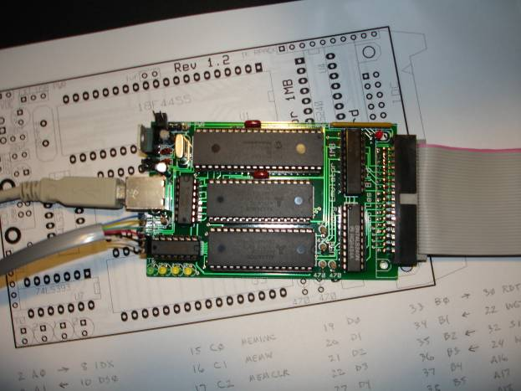

USB Floppy Emulator 1MB

JUMPER WIRE FOR REV 1.2
An error in the REV 1.2 design needs to be corrected for proper function of the device. When I submitted the design to the PCB manufacturer I forgot to complete the layout of the power track. As a result of this error, chip U3, U6 and U7 do not have +5V to their power pins. A jumper wire needs to be installed as shown in the following photo to fix this error. Pin 32 of U2 needs to be jumpered to pin 32 of U3. Also you should jumper pin 34 of the IDC connector to +5V for powering the terminating resistor pack on the edge card floppy adapter.

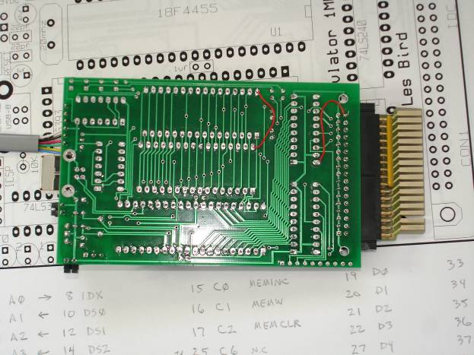

USB Floppy Emulator 1MB (Component Layout)

Building the USB Floppy Emulator 1MB is very straight-forward and simple. All components are labeled on the silkscreen so there’s no confusion as to where something goes. The only tricky parts are orienting some of the components. The LEDs should be oriented so that the long lead is towards the top of the PCB. The top of the PCB is designated by the silkscreen label that reads “Rev 1.2”. The regulator should be oriented as indicated below with pin 1 (voltage in) towards the bottom and pin 3 (voltage out) towards the top. Pay close attention to the silkscreen for the orientation of the capacitors.
Note that if you do not wish to use an external power adapter then you do not need to install the 5V regulator and 47uf capacitor. Make sure the jumper is set to USB power if this is the case.
A PIC18F4450 can be used instead of the PIC18F4455 if it’s easier to find. I use the 18F4450 myself. I also use Alliance 512Kx8 SRAM (AS6C4008-55PCN).
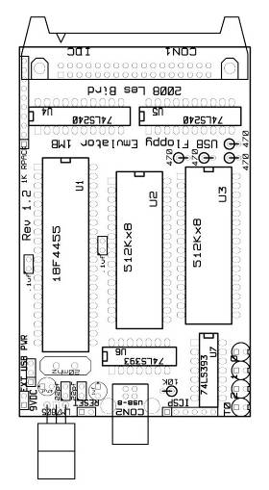

USB Floppy Emulator 1MB (PCB)

This photo shows the blank PCB which measures only 4” x 2.5”. There is no schematic available. The component and track layout was done manually and not auto generated from a schematic. The device is simple to build and the parts are easily acquired from common suppliers.

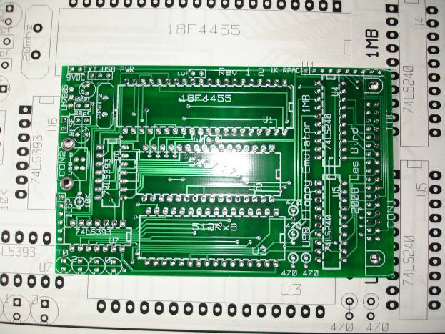

Questions? Ideas? Comments? E-mail me at lesbird@bellsouth.net. I’d like to read them.

THE END

